Computer Networks Homework

Transport Layer

1. Compute 8-bit checksum for 01100010 and 10111001, and use an example to show that if the two numbers each has a 1-bit error, the checksum can not detect the errors.
2. Consider the following cwnd evolution at a TCP sender:

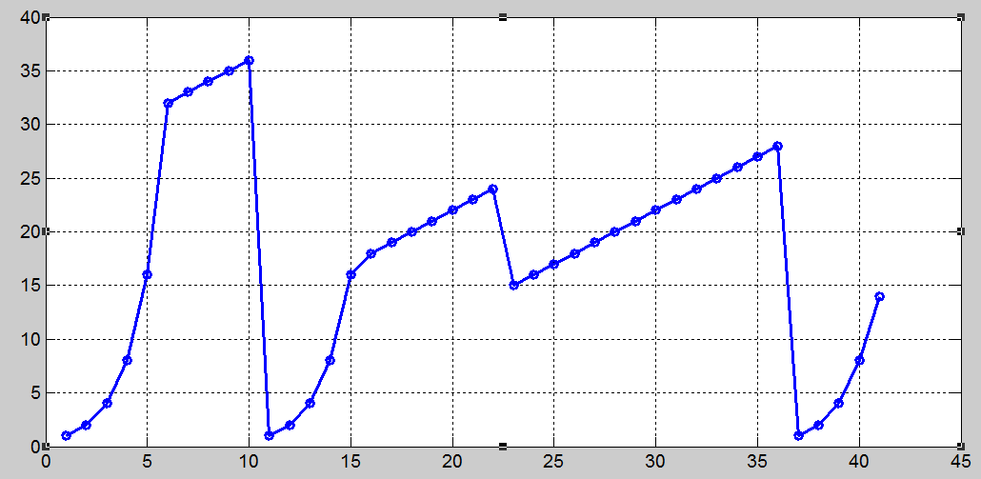

1. Is this TCP Tahoe or TCP Reno?
2. What is the sender’s initial ssthresh?
3. What happens at time 10? What is ssthresh and cwnd at time 11?
4. What happens at time 22? What is ssthresh and cwnd at time 23?
5. What happens at time 36? What is ssthresh and cwnd at time 37?
6. When is the 50th segment is sent?
7. Which intervals the TCP connection is under slow start?
8. Host A sets up a TCP connection with Host B, fill in the blanks the appropriate sequence and acknowledgement numbers.

  

80

75

75

50

30

30

70

40

40

40

1. Two TCP connections A and B strictly follow AIMD and they share a same bottleneck of 100 Mbps. Initially connection A has a throughput of 64 Mbps, connection B has a throughput of 32 Mbps, the two connections increase their throughputs at a same rate. 1) Fill in following table. 2) After how many loss events, the difference between the two connections’ throughputs is within 5 Mbps?

|  |  |  |
| --- | --- | --- |
| Round | A | B |
| 1st loss event | 64🡪66🡪33 | 32🡪34🡪17 |
| 2nd loss event |  |  |
| 3rd loss event |  |  |
| 4th loss event |  |  |